**. Grid and Column System:**

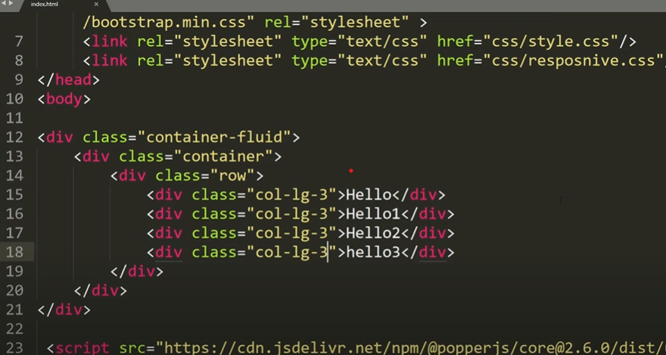

**. Auto column layout:**

if you can't calculate or divide grid, div so you can apply this

eg: col-lg, col-md

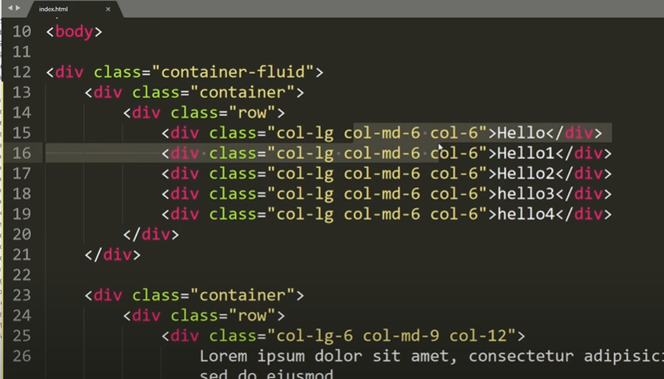

**Row column classes**

"it means define what no of column we need in a row"

row-cols-#NUM or row-cols-lg-#NUM

**Gutter class --**g

gx means padding left to right.

gy means margin top to bottom.

**Text related class**

a/ text-align

text-start, text-center, text-end

**/ text-break**

means break word.

**/ Text transform**

text-uppercase, text-capitalize, text-lowercase

**/ Font size**

fs-1 = 2.5rem = 40px

fs-2 = 2rem = 32px

fs-3 =1.75rem = 28px

fs-4 = 1.5rem = 24px

fs-5 = 1rem = 16px

**/ Font weight and italics**

fw-bold, fw-bolder, fw-boldest

fw-lighter, fw-light

fw-normal

fw-italic

**margin and padding class:**

by default margin and padding is 16px=1rem

•m - for classes that set margin

•p - for classes that set padding

t- for classes that set margin-top or padding-top

b- for classes that set margin-bottom or padding-bottom

s- (start) for classes that set margin-left or padding-left in LTR, margin-right or padding-right in RTL

e - (end) for classes that set margin-right or padding-right in LTR, margin-left or padding-left in RTL

x - for classes that set both *-left and *-right

y - for classes that set both *-top and *-bottom

if you need to set from both 4 sides then use only "p" or "m"

**size:**

|  |  |  |
| --- | --- | --- |
| p-1 =  p-2 =  p-3 =  p-4 =  p-5 = | = .25 rem  = .5 rem  = 1 rem  = 1.5 rem  = 3 rem | 4px  8px  16px  24px  48px |

**Background & Gradients Classes**

Background color

Bg-color or Gradient-color

**What are Clear and Float Classes**

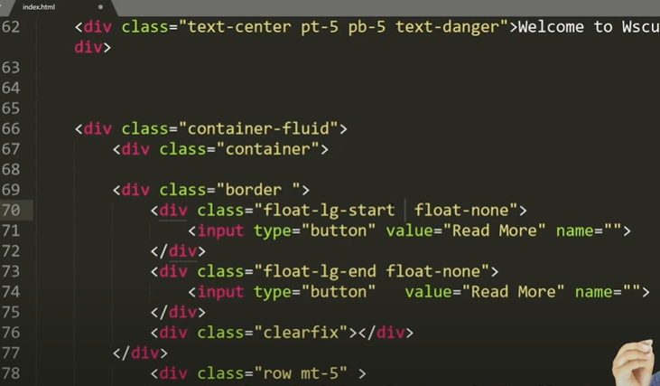

**Image Responsive**

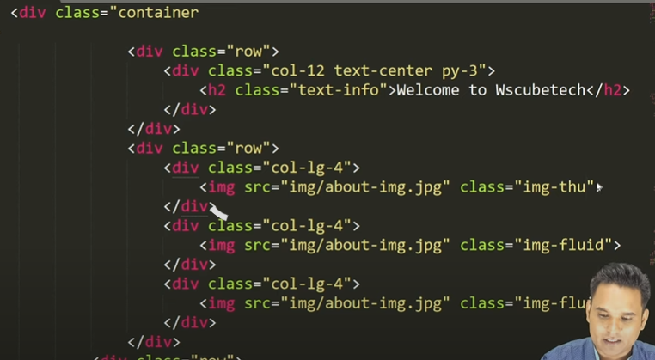

**Button Classes**

**Card Layout**

**Responsive**